**Deductive Proofs**

Class Examples

1.

What reasons can you give to prove that **?**



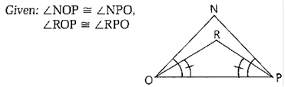 2.

What reasons can you give to prove that  **∠NOR ≅ ∠NPR** ?

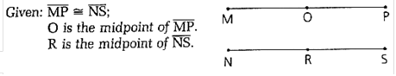 3.

What reason can you give to prove that  **?**

Homework

B

X

A

1. Prove

D

C

2. (GFEC page 32, #6. Determine of M is the midpoint of OP, then write a 2 column proof showing your determination.)

3. (GFEC page 33, #10)

4. (GFEC page 64, #2)

5. (GFEC page 64, #7)

6. Write a definition here for the word “oblique” found within problem #9 on page 65 of your textbook.

7. (GFEC page 65, number 14. Find all measures of all angles.)

C

8.

A

R

D

Given: $CR ≅ AD$

What can you deduce about CA and RD ?